1.Launch one aws ec2 and install Jenkins.
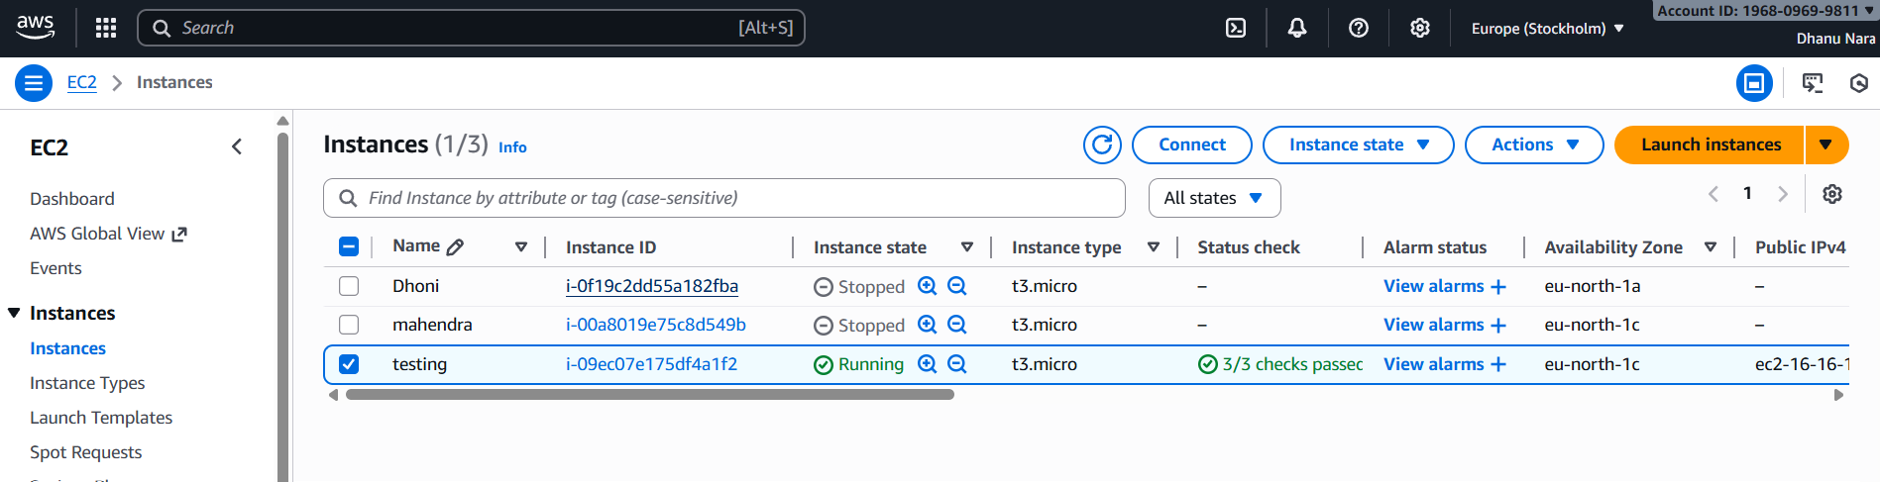
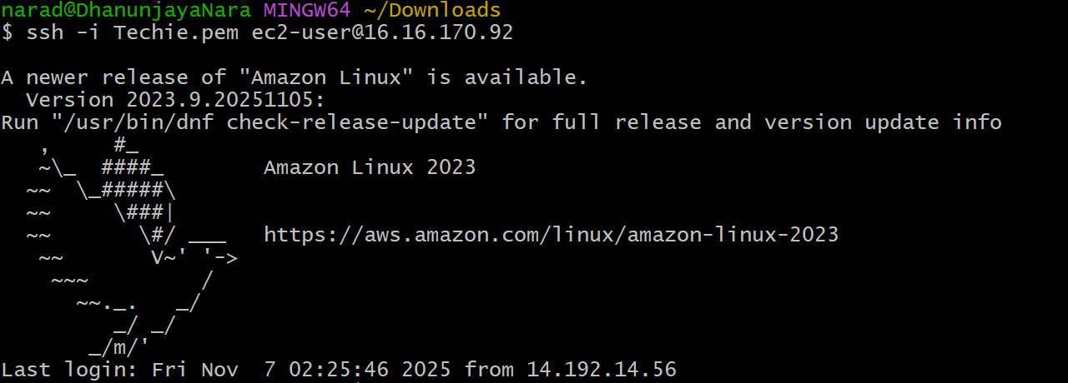
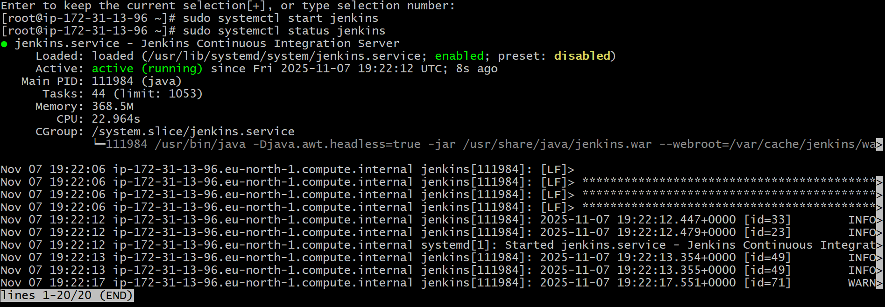

2.Setup Apache Tomcat on ubuntu virtual machine.

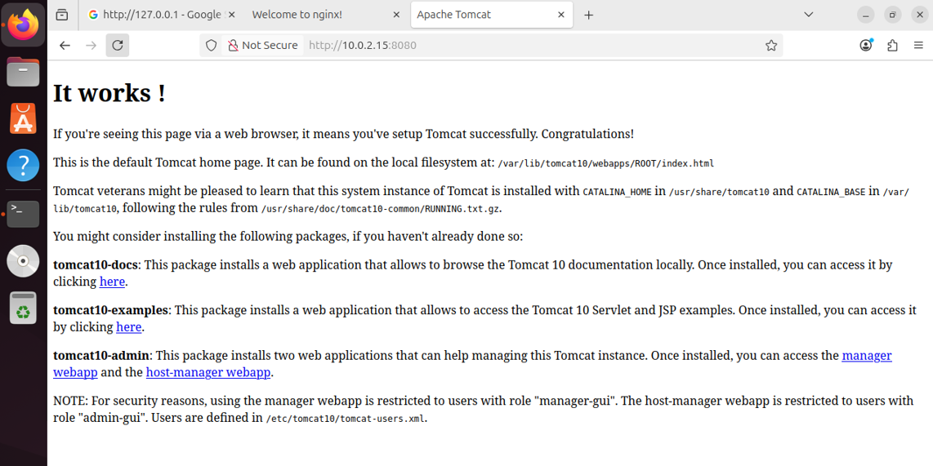

3.Setup Docker Desktop on your local windows. 